A generated mission scenario is given in page 2. Given the mission scenario, could you provide an example of the flight brief and learning outcomes the flight lead and instructor may come up with?

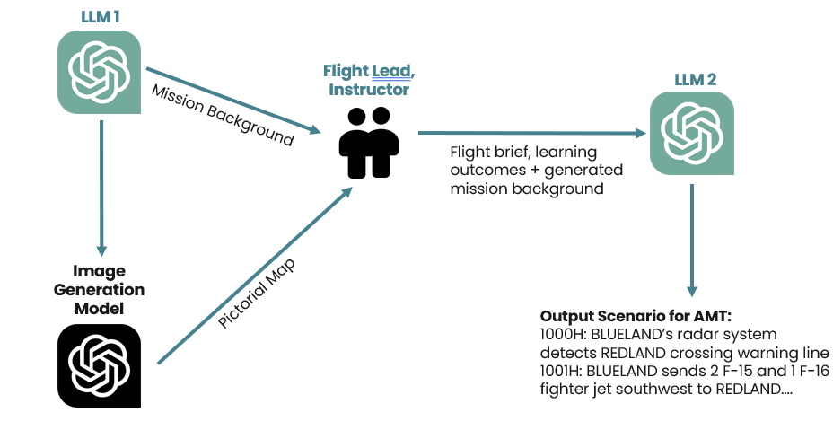

If you feel that the mission background is inappropriate or not detailed enough, feel free to edit or substantiate it based on your own expertise!

Thank you! 😊

**Mission Scenario**

## Training Scenario: Operation Crimson Echo

**Commander’s Intent:**

* Destroy the underground command center. Disable the communication infrastructure. Damage the bunkers beyond repair.

* 100% bombs on time and on target

* Maximum 50% BLUELAND Air Force losses

* 100% REDLAND Air Force destruction

**Force Composition:**

* REDLAND Air Force: four SA-7 surface-to-air missile launchers and three ZSU-23-4 Shilka self-propelled anti-aircraft gun systems.

* REDLAND Ground Forces: 500 troops guarding the facility, armed with small arms and heavy machine guns. There are no known armored vehicles present.

**Geography:**

* Distance to REDLAND threats: SAM Regiment: 10 nm north and 15 nm east of the target, Airbase: 20 nm south of the target

* Environmental Conditions: Nighttime mission, with scattered clouds and visibility of 5 nm. Target located in an urban area, with surrounding buildings and narrow streets

**Surrounding Conditions:**

* REDLAND's Air Force is on high alert, with increased air patrols in the area

* REDLAND's ground forces are conducting exercises 30 nm north of the target, but are not expected to interfere with the air strike mission

* BLUELAND's intelligence suggests that REDLAND has recently reinforced its air defenses in the area, but the extent of the reinforcements is unknown

**Target(s) Details:**

* Central military complex consists of 5 underground bunkers, an underground command center, and hardened communication infrastructure.

* Bunkers are reinforced with steel and ceramic armor.

* Command center is protected by thick blast doors and advanced security protocols.

**Rules of Engagement:**

* REDLAND forces are considered hostile and will respond defensively upon detection of incoming aircraft.

* They are not authorized to initiate contact unless provoked.

* Friendly fire prevention measures must be taken to minimize collateral damage to civilians and non-target structures.

* Only authorized military targets within the defined engagement zone shall be engaged.

**Flight Brief and Learning Outcome**